**EE 185**

Homework Rubric

horizontal line

Homeworks should be a reflection of your learning and development. They should show careful thought and demonstrate methods learned in class. Rubrics for homework will change throughout the semester to reflect how things like organization should become second nature. Homeworks will be graded on the following scale:

|  |  |  |
| --- | --- | --- |
| **Category** | **Student Score** | **Grader Score** |
| **Organization** | | |
| **Basics** | **1/1** | **/1** |
| **Structure** | **2/2** | **/2** |
| **References** | **1/1** | **/1** |
| **Work** | | |
| **Effort** | **1.75/2** | **/2** |
| **Clarity** | **1.75/2** | **/2** |
| **Discussion** | **1.75/2** | **/2** |
|  |  |  |
| **Total** | **9.25/10** | **/10** |

**Please fill the Rubric, thoughtfully, and also only load 1 file for the HW**

**Problem 1:**

i)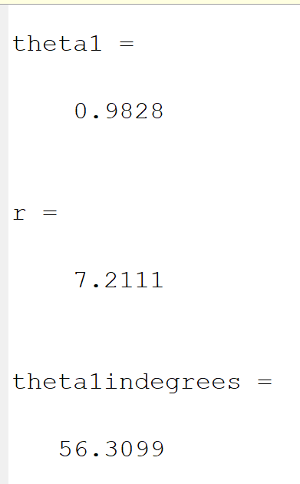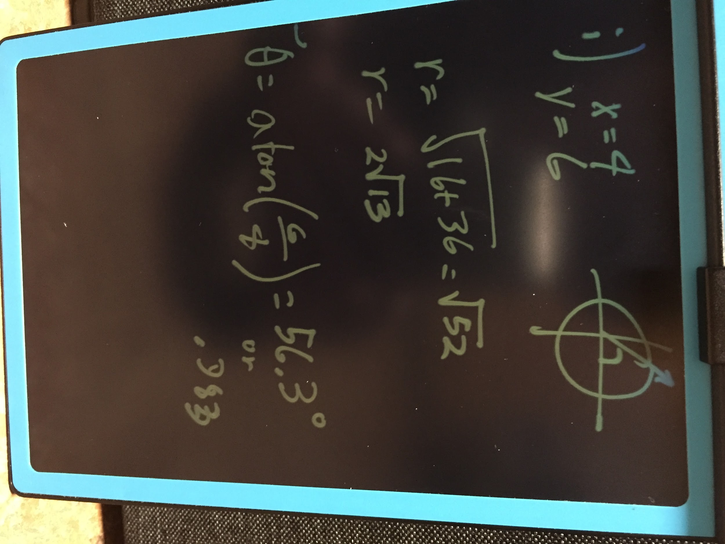

ii)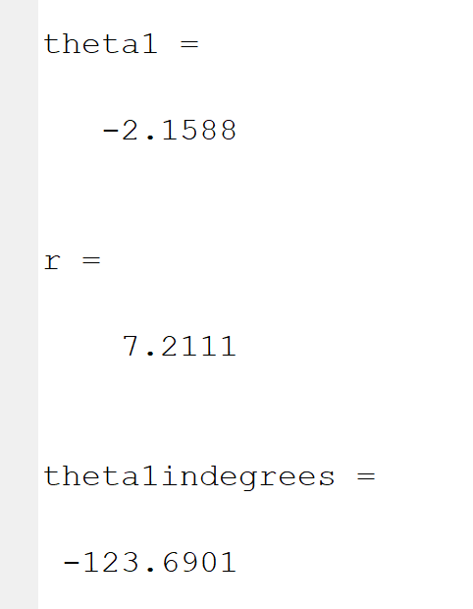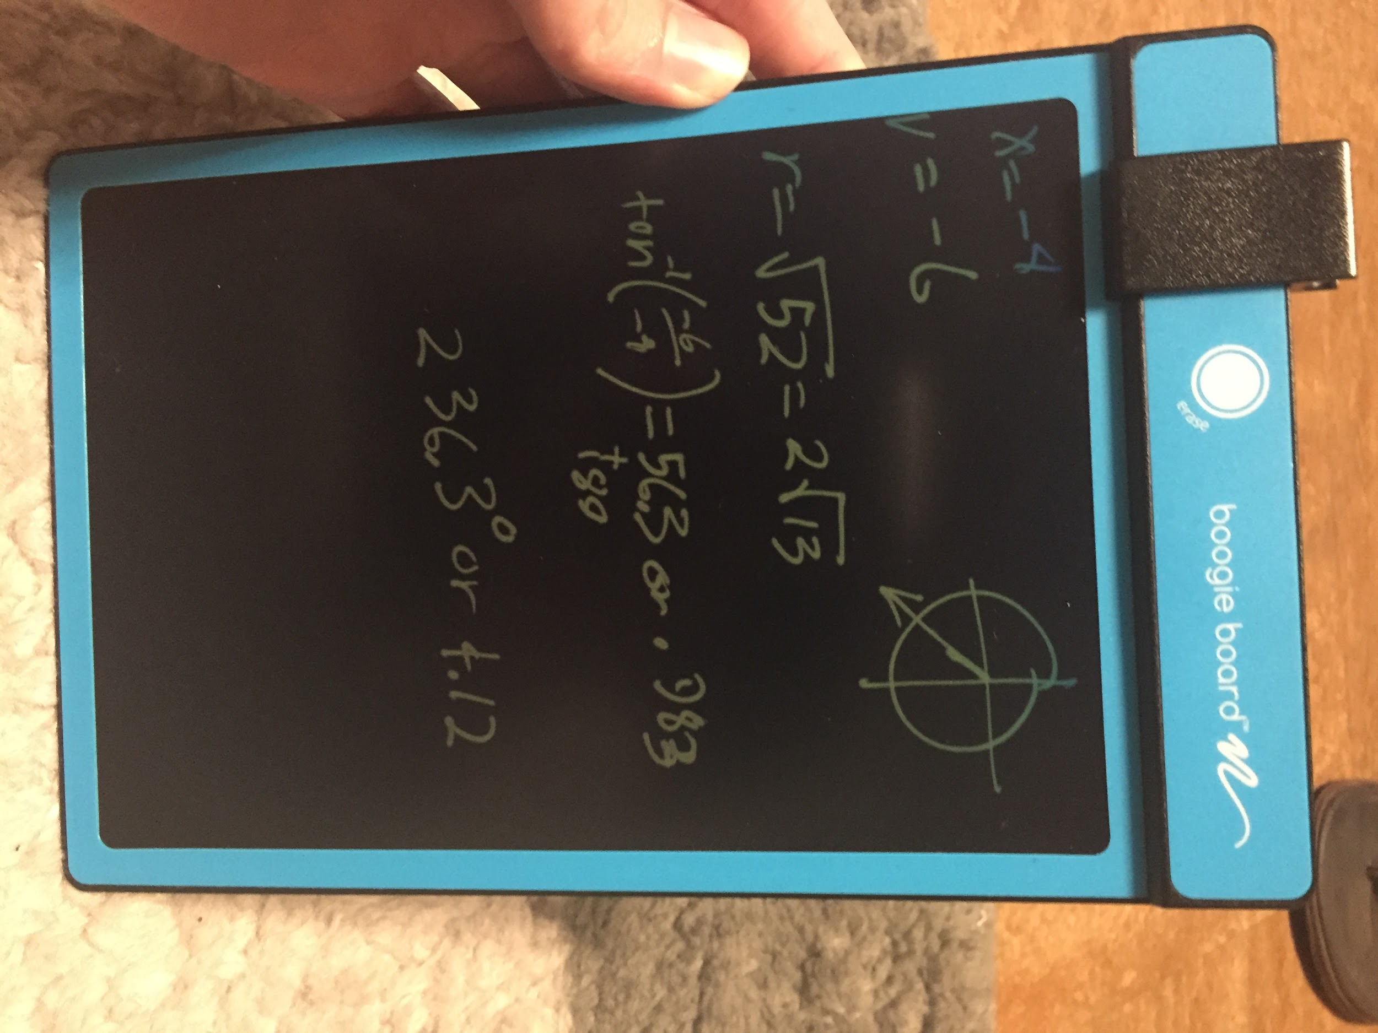

iii)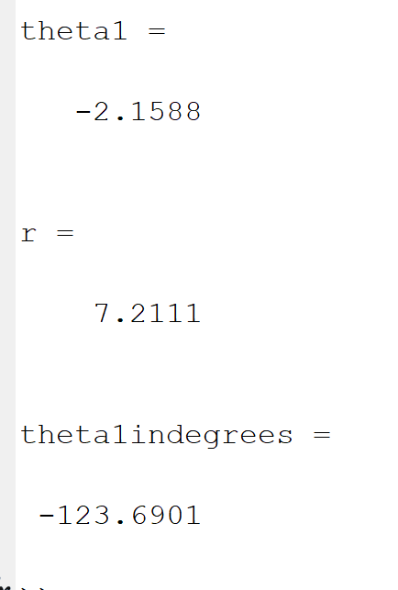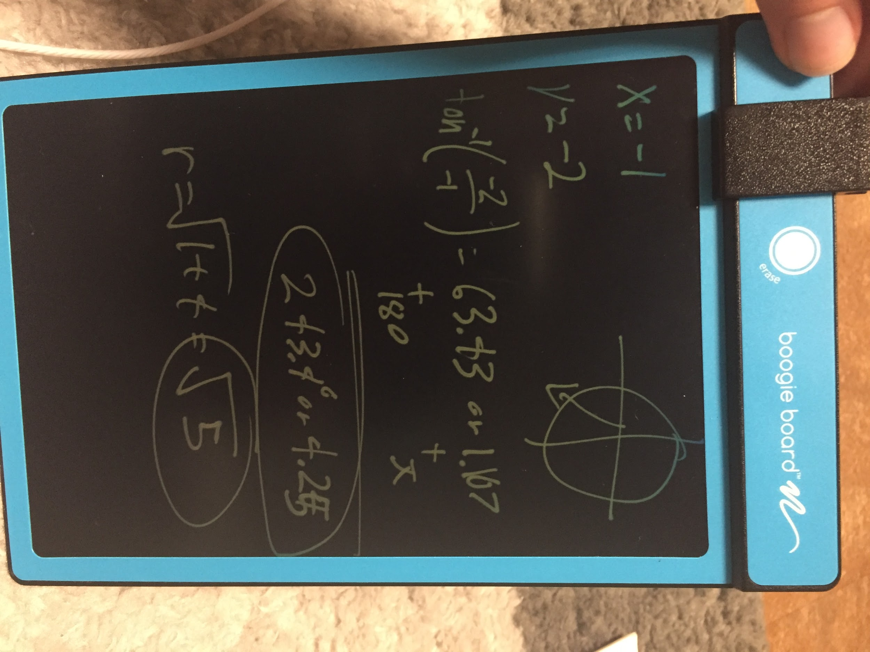

iv)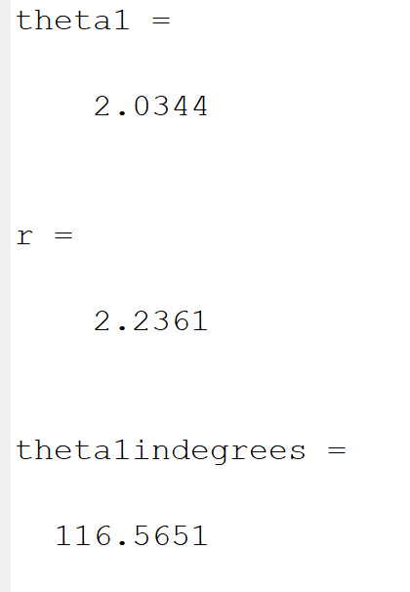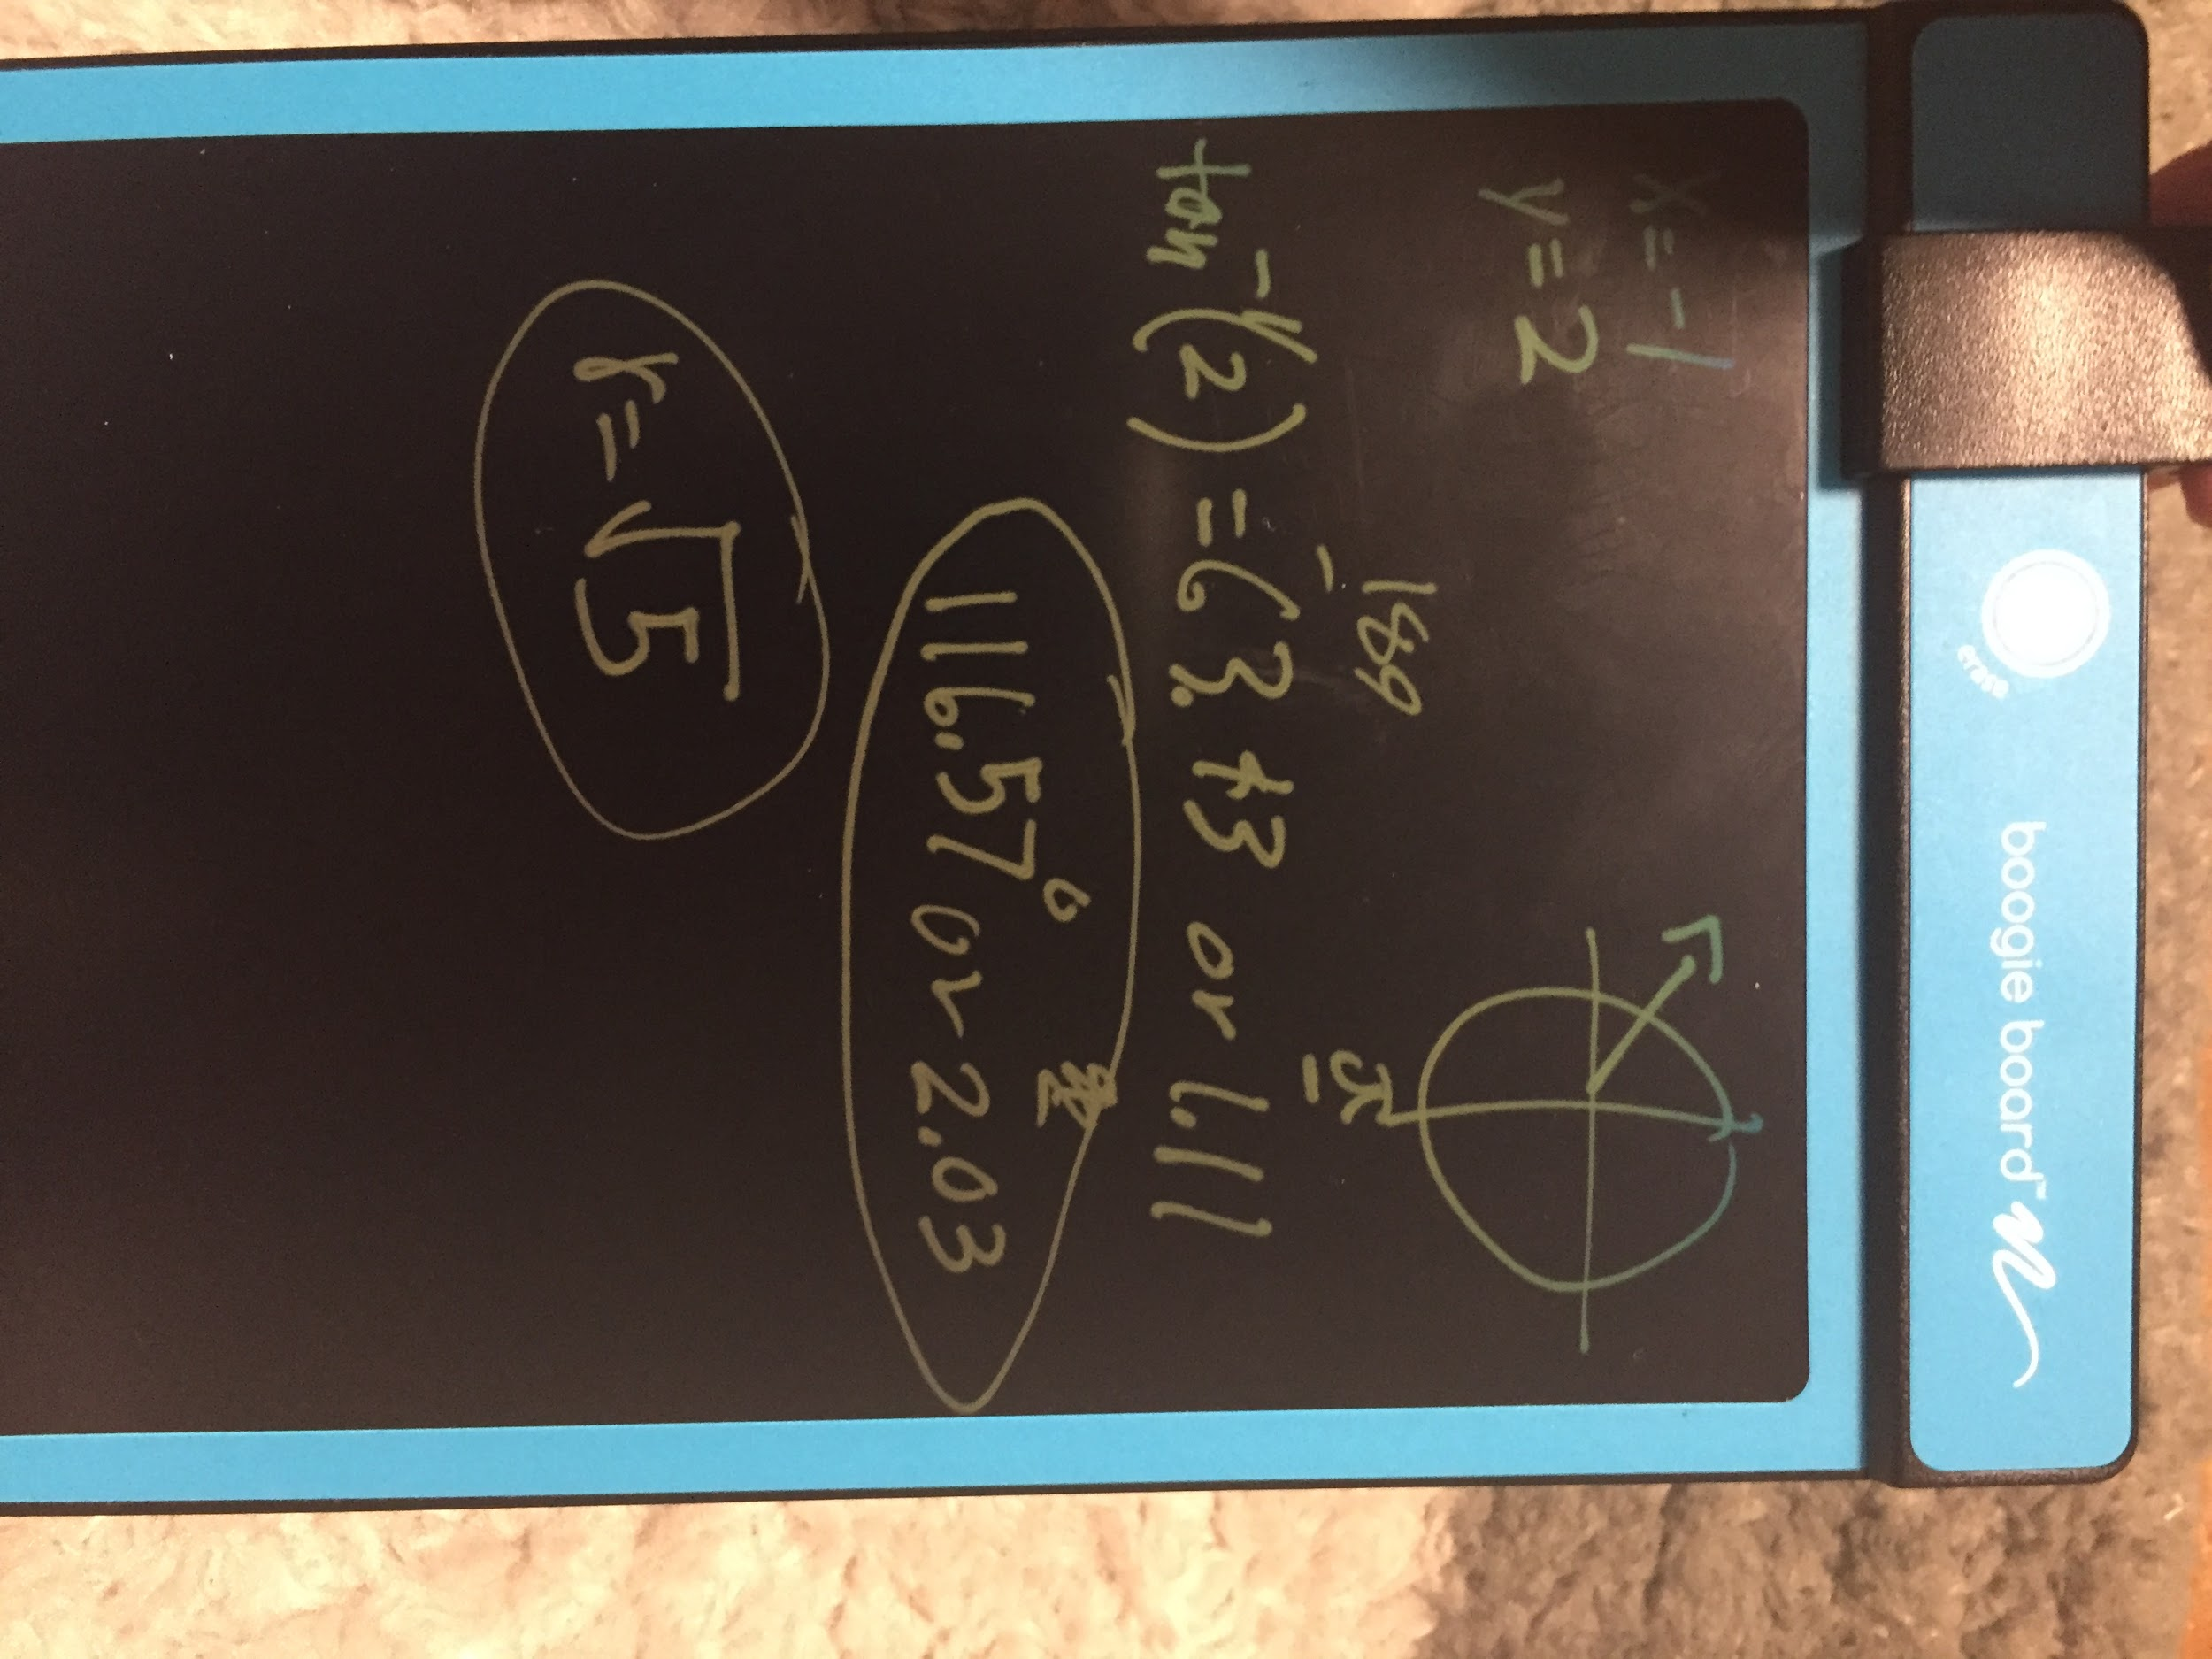

1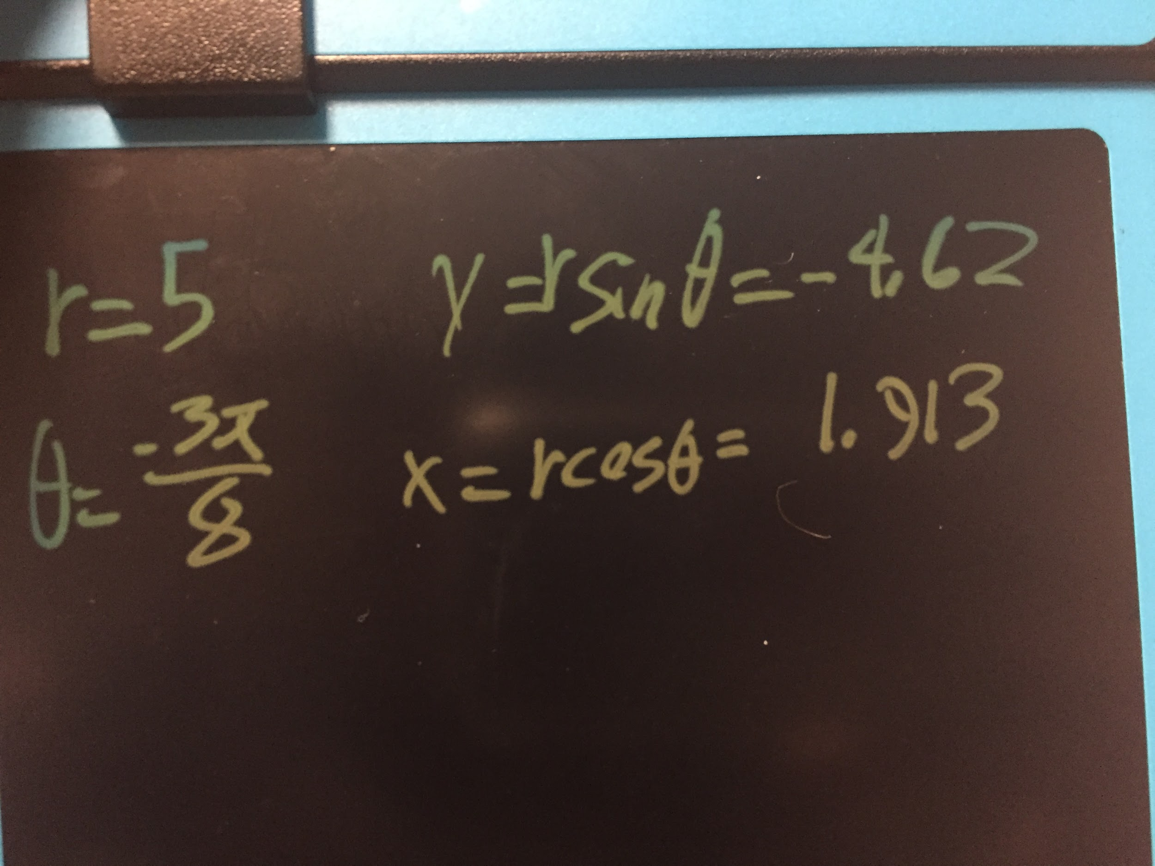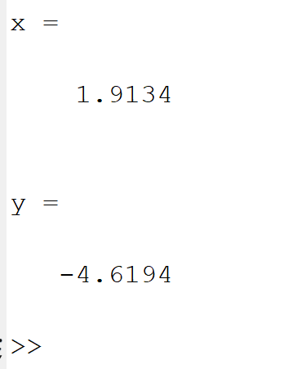

2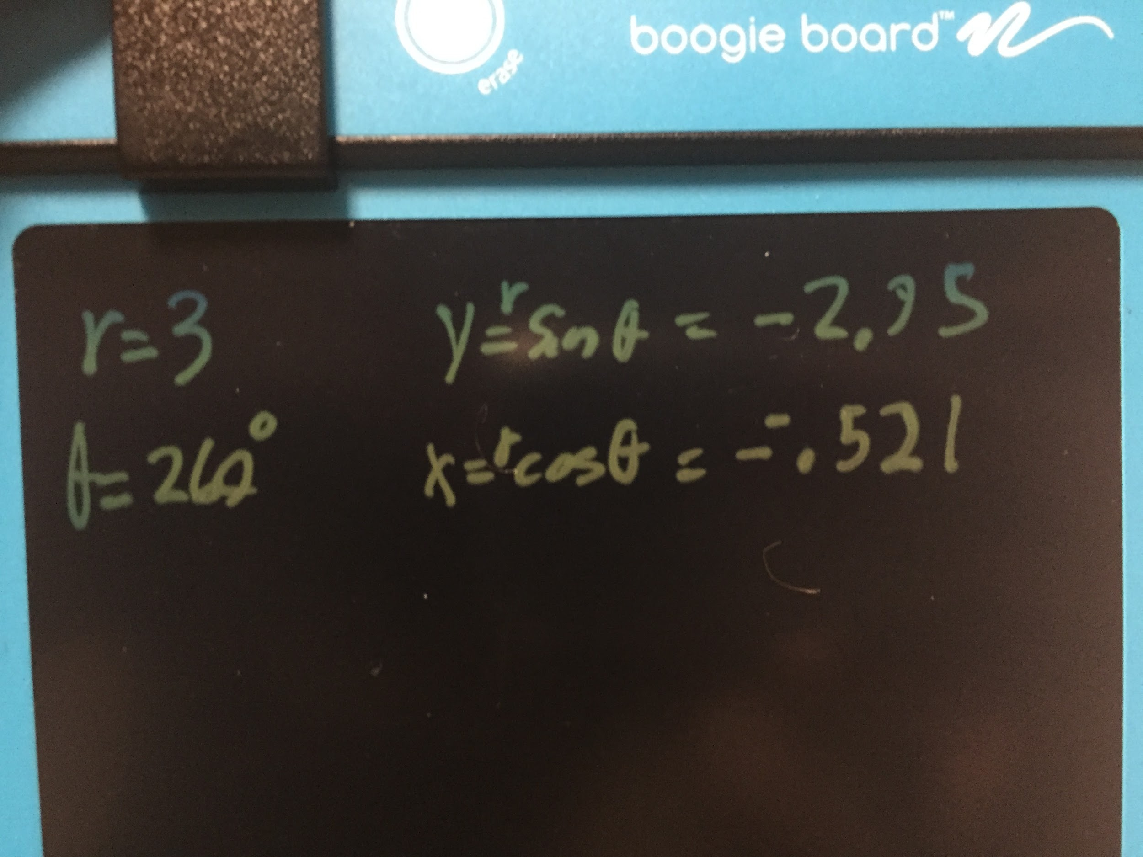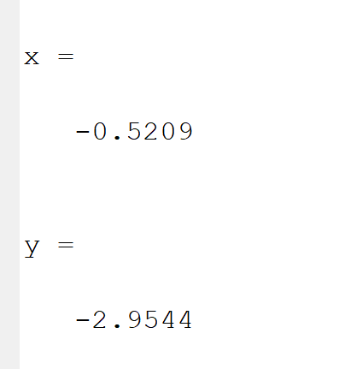

3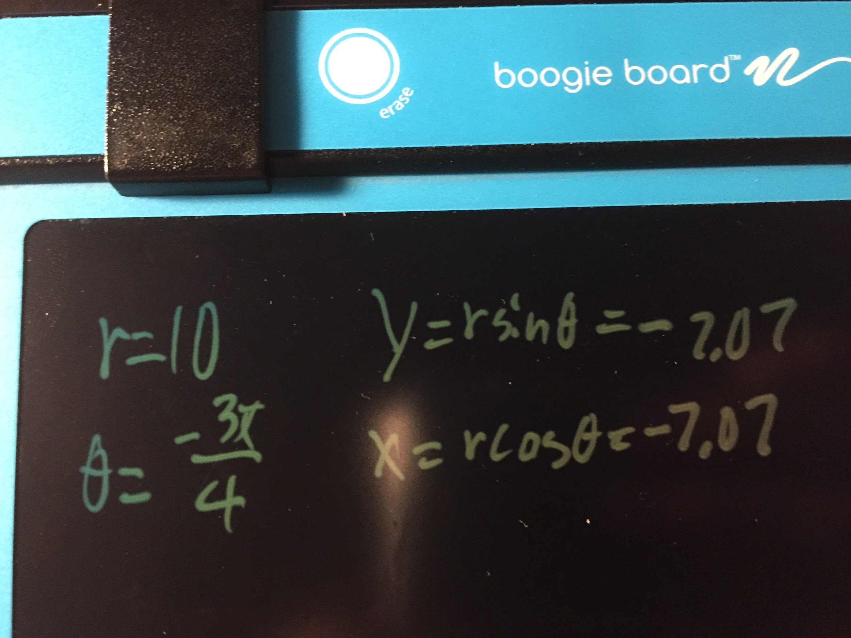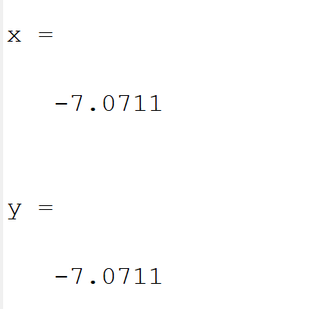

4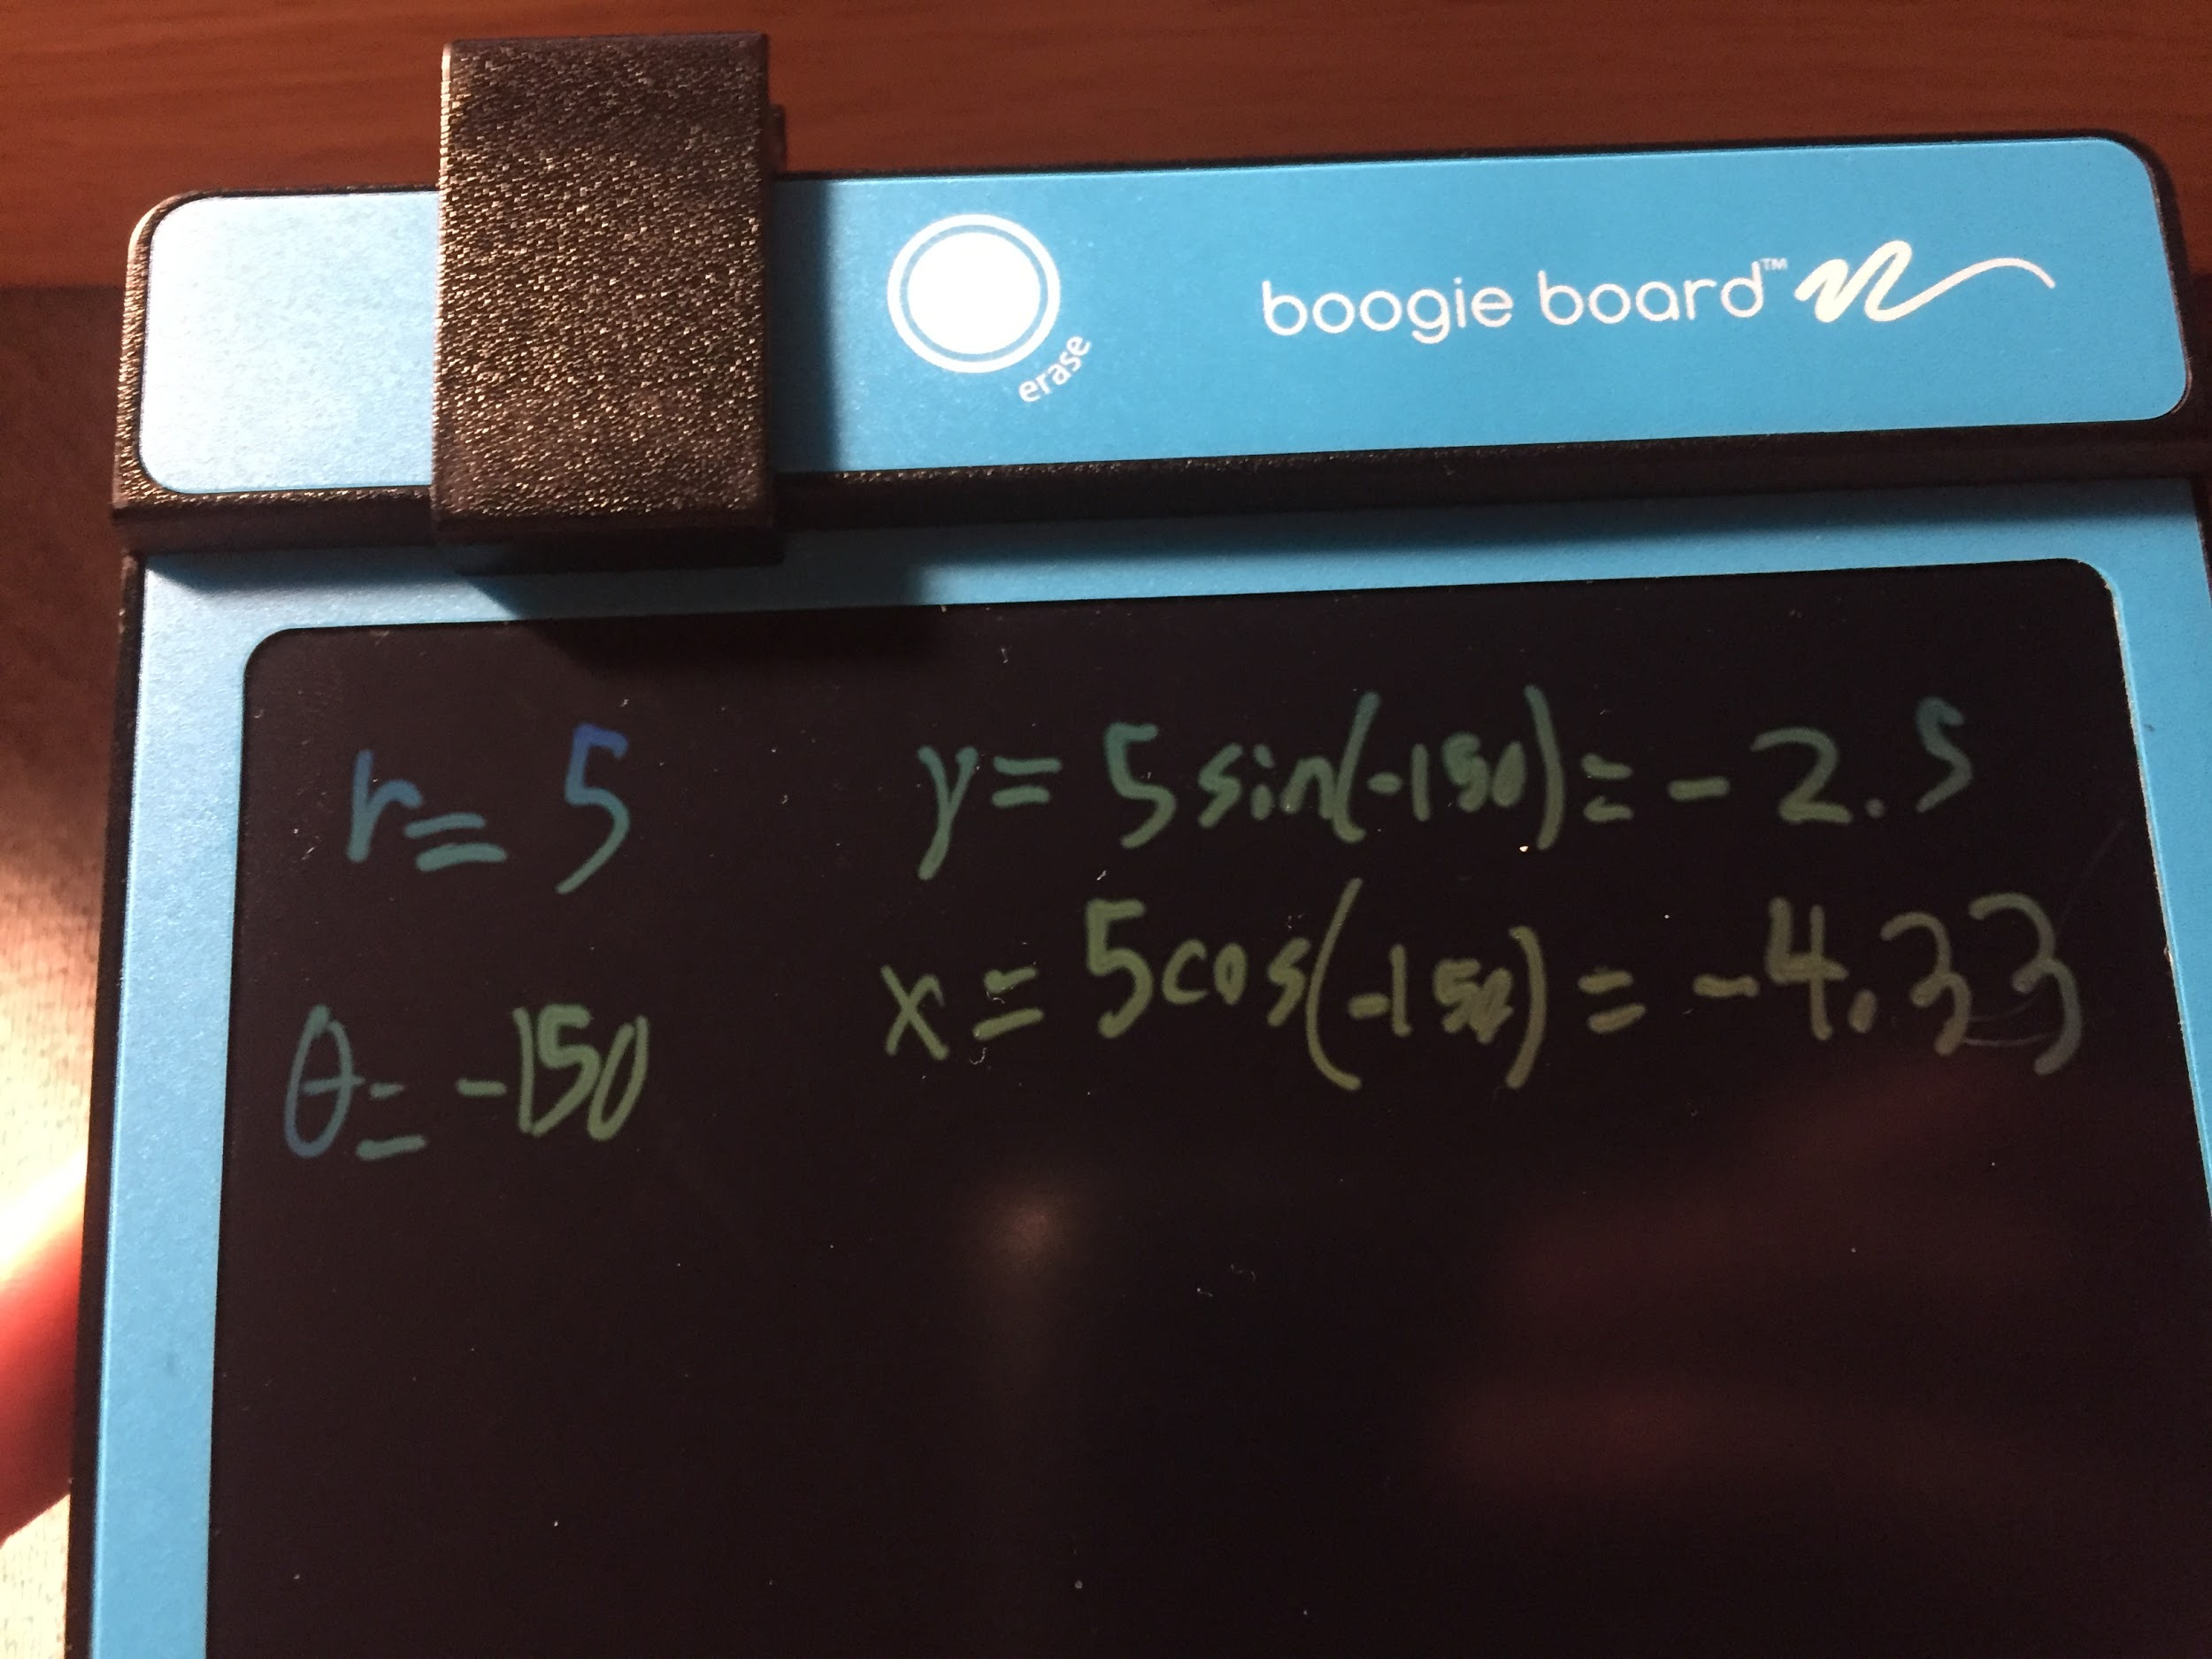

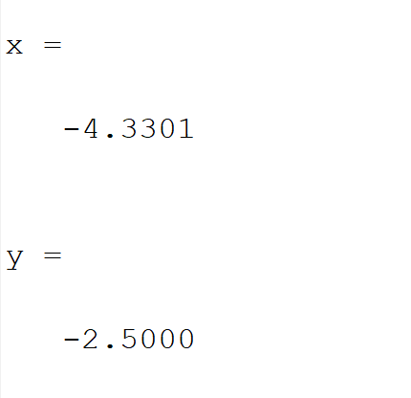

5

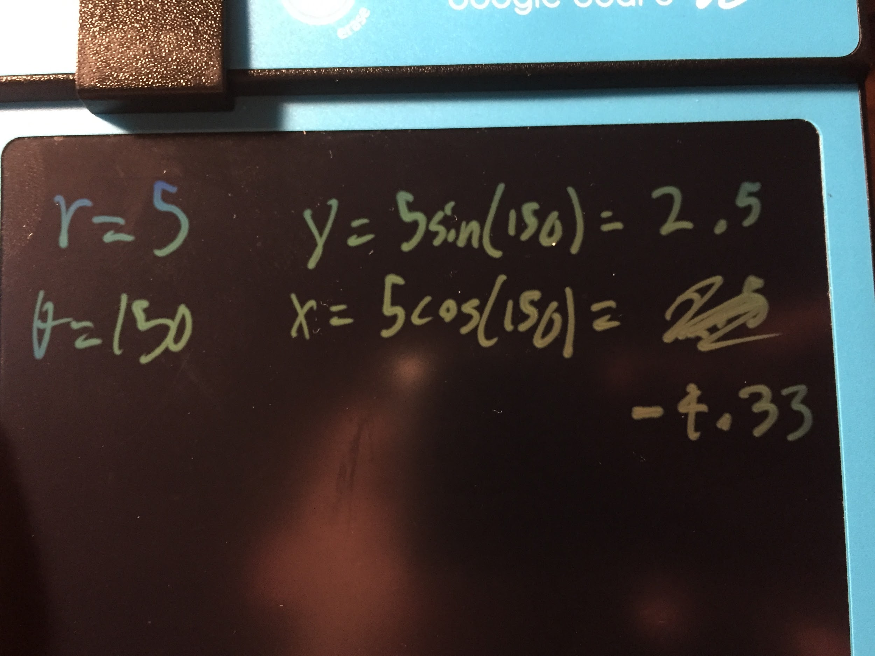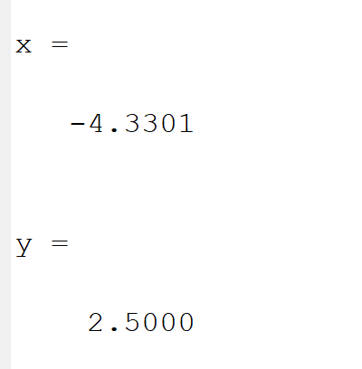

**Problem 2:**

After looking over the lessons I made this program that mimics the original polar question but returns the radius as a radical rather than exact answer and fixes the angle.

%%

clc

x = input("What is x? ");

y = input("What is y? ");

[out ,in] = simplfySquareRooter(x^2 + y^2);

disp("r is " + out + " square root: " + in);

baseAngle = atan(abs(y/x));

disp("base angle: " + baseAngle);

%find the angle

if(x>0 & y >0) %quad 1

disp("first quad");

angle = baseAngle;

elseif(x<0 & y>0) %quad 2

disp("secound quad");

angle = pi - baseAngle;

elseif(x<0 & y<0) %quad 3

disp("third quad");

angle = pi + baseAngle;

elseif(x>0 & y<0) %quad 4

disp("forth quad");

angle = 2*pi - baseAngle;

end

%angle= angle/pi;

disp("angle is: " + angle);

disp("or angle is: " + (180*angle)/(pi));

%%

[x , y] = simplfySquareRooter(60);

disp (x + " " + y);

%a short list of primes for faster solving

function [out, in] = simplfySquareRooter(x)

primes = [2,3,5,7,11,13,17, 19, 23, 29, 31, 37, 41, 43, 47, 53];

tempNum = x;

i = 1;

out=1;

while((primes(i)^2) <= tempNum)

if(mod(tempNum,(primes(i)^2)) ==0)

tempNum = tempNum/(primes(i)^2);

out = out* primes(i);

else

i= i+ 1;

end

end

in = tempNum;

end

What did you think about the site?

It seems like a good resource but I don’t think I would use it very much because it would be faster to look at examples for the exact problem/question you have. It seems good for a basic understanding of how the elements of matlab work together and what is possible.

What did you learn from the site?

I learned that if else statements use “end” rather than “{“ brackets.

To make new rows in arrays you use the “;” rather than having two “[“, I wonder if this means you cannot make 3 dimension arrays.

**Problem 3:**

If you do think there is, solve for the kids’ ages and show your solution.

If you do not think it is possible, explain why, and what you need and then

explain how you would solve it.

You shouldn’t be able to solve it because you should need 3 inequalities for 3 unknown variables. Also we don’t know her office number.

If we knew one age or another equality such as:

first kid age + second kid age = 10

as well as her office number we could find out the kids' ages.

**Problem 4:**

What level do you think this book is for? High school, first year EE, 2nd year EE or

higher level? Why?

I think it is written for 1st year EE or 2nd year. I think this because a lot of the topics in the book seem to be the basic concepts of EE. I don’t feel that it conveys that through the writing because it seems to expect a level of understanding of calculus and higher math. It also seems to expect the reader to understand a lot of jargon and doesn’t explain new concepts in more than one way.

What do you find interesting about the book? Describe what it is and why?

It seems to have a lot of mathematical formulas and seems to have explanations but only explaining things one way expecting the reader to understand based on a 1 sentence of definition.

In the book it says, “ Sequences are fundamentally different than continuous-time signals. For example, continuity has no meaning for sequences”. This explanation makes sense but an example to go along would be better for people to understand this concept. Such as, sequences are more like a list of numbers (ex: [1,2,4,5,3]) they don’t have inbetweens, whereas analog signals are more like functions they are continuous.

Which subject is of your interest? Why?

I like the concept of “Digital Signal Processing” because it is interesting to learn how engineers break up continuous things such as time and voltage into bits for better communication.